Guide
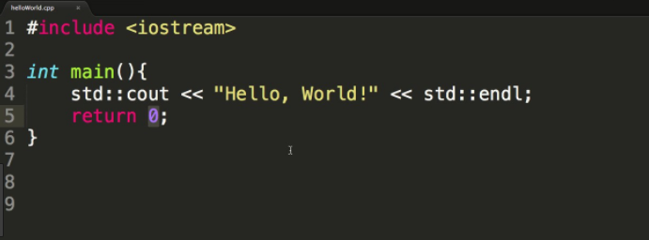
https://www.learnpython.org/en/Hello,_World!
x = 1
if x == 1:
# indented four spaces
print("x is 1.")

